Lessons between Tyre and Babylon
International Convention 2018

We bring you the love and greetings from your brethren with whom we meet in Oakland County Bible Students as well as the many brethren we co-labor with in the Harvest work, including those in India, Sri Lanka, Myanmar, Uganda, D. R. Congo, Kenya, Rwanda, Nigeria, Tanzania, Australia, Germany, Canada and the USA.

We are all aware that the Bible teaches that literal Babylon symbolically represents Papacy and, at times, all the nominal Church systems, including the Protestant daughter harlots (see Revelation 17:5).

But we would like to give scriptural suggestions that indicate that another city, Tyre, also represents Papacy and, at times, all the nominal Church systems.

We read in Ezekiel 28:1, 2: “The word of the LORD came again unto me, saying, Son of man, say unto the prince of Tyrus (Tyre), Thus saith the Lord God; because thine heart is lifted up, and thou hast said, I am a God, I sit in the seat of God, in the midst of the seas, yet thou art a man, and not god, though thou set thine heart as the heart of God.”

Now we will compare 2 Thessalonians 2:3 and 4: “Let no man deceive you by any means, for that day shall not come, except there come a falling away first, and that man of sin be revealed, the son of perdition: who opposeth and exalteth himself above all that is called God, or that is worshipped, so that he as God sitteth in the temple of God, showing himself that he is God.”

We know from our previous studies that the “man of sin” represents the line of Popes, who present themselves as God’s authority on earth. So, too, the “prince of Tyre” similarly represents the line of Popes.

In Ezekiel 28:12 we read: “Son of man, take up a lamentation upon the king of Tyre, and say unto him, thus saith the Lord God, thou sealest up the sum, full of wisdom, and perfect in beauty.”

The “king of Tyre” represents Satan, the father or creator of the Papal system with their line of popes represented in the “prince of Tyre.”

Next we want to consider a hidden time prophecy concerning Tyre that is being fulfilled. It is in Isaiah 23:15-17.

Verse 15: “And it shall come to pass in that day, that Tyre shall be forgotten seventy years, according to the days of one king, after the end of seventy years shall Tyre sing as a harlot.”
“In that day” represents the thousand-year day of Christ’s presence starting upon his return in 1874.

“Tyre” represents Papacy.

“Forgotten seventy years” represents that the Papacy was not prominent in world affairs and would not be so during a seventy-year length of time, transpiring sometime after 1874.

“In the days of one king” might have two interpretations:

The first one, starting in 1914 when the Gentile Times ended, and only Jesus was recognized by God as king and ending in 1984 (70 years), when the USA began diplomatic relations with the Vatican by establishing an embassy with them. This was done by President Ronald Reagan and Pope John Paul 2. The purpose of their new relationship was to work together to bring down Communism. (see page 10 and read: “Time magazine February 24, 1992. Holy Alliance, How Reagan and the Pope conspired to assist Poland’s Solidarity movement and hasten the demise of Communism, an investigative report.”)

President Ronald Reagan at that time colluded with the Pope and they worked together with the CIA and with the Pope’s intelligence community in Poland to sustain Solidarity, the Polish labor union, which brought down communism in Poland. When the Pope flew into Poland to visit for the first time the communists had to back down. They couldn’t criticize him or arrest him because the people loved him and flooded the streets. That was the turning point in the collapse of Communism.

The second interpretation starts in 1918 and ends in 1989 (70 years) with the fall of the Berlin wall, the “one king” being communism. Similarly, the Papacy under John Paul 2 and President Reagan had a decisive role.

Verses 16 and 17: “Take a harp, go about the city, thou harlot that has been forgotten, make sweet melody, sing many songs, that thou mayest be remembered. And it shall come to pass after the end of seventy years, that the LORD will visit Tyre, and she shall RETURN (Leeser’s translation), to her hire, and shall commit fornication with all the kingdoms of the world upon the face of the earth.”

The harlot is Papacy.

Singing many songs and making sweet melody represents that the Papacy, since John Paul 2, has been much more attractive to world politicians and leaders. In part, this is because the Popes present themselves as the world’s conscience, standing up for the poor and oppressed.
“Returning to her hire,” that of a harlot, means that the Papacy is once again aspiring to be in relationships with worldly “political kings;” many of the world leaders since have had their various degrees of involvement with her.

“Returning” means that this is a second attempt at being a harlot. A repeat act so to speak.

All the sitting US presidents since Dwight Eisenhower have traveled to the Vatican to visit the Pope.

On President Donald Trump’s first trip abroad to visit world leaders he made three stops. The first was to Saudi Arabia, the home of Islam. The second was to Israel, the home of Judaism; and the third was to the Vatican, representative of the largest Nominal Christian denomination.

The phrase “shall commit fornication with all the kingdoms of the world upon the face of the earth,” means that now the Papacy is a “global player.” That is, the Vatican has active relationships with many different world leaders, not just European countries as in the past.

We should be greatly encouraged to realize that Bro. Russell did not comment on this time prophecy. It was hidden in order for it to be understood in due time. God had it here all along and kept it hidden as a way to encourage those of us who are living now in order to have our faith confirmed although we are living this far past 1914. It is also important to understand that the foregoing interpretations are in harmony with what Bro. Russell expected from the scriptures.

Next we will consider Tyre in Ezekiel, the 26th and 27th chapters.

Ezekiel 26:2-4: “Son of man, because that Tyre has said against Jerusalem, Aha, she’s broken who was the gate of the people. She is turned unto me. I shall be replenished, now she is laid waste. Therefore, thus saith the Lord God, behold, I am against thee O Tyre, and will cause many nations to come up against thee, as the sea causeth the waves to come up. And they shall destroy the walls of Tyre and break down her towers. They shall scrape her dust from her and make her like the top of a rock.”

And verse 14: “And I will make thee like the top of a rock, thou shall be a place to spread nets upon, thou shalt be built no more, for I the LORD have spoken it, saith the Lord God.”

Literal Tyre was mocking Jerusalem when they were destroyed by Nebuchadnezzar in 607/606 B. C. The Lord prophesied that He was going to destroy Tyre because of this. This destruction was accomplished in two phases. First the mainland city of ancient Tyre on the coast of modern day Lebanon was destroyed. In verse 7 it reads: “for thus saith the Lord, Behold, I will bring up on Tyre Nebuchadnezzar King of Babylon, a king of kings, from the north with horses and with chariots and with horsemen in companies and much people.” This tells us that Nebuchadnezzar was appointed of God to conquer literal Tyre. And the following verses 8-11 describe how Nebuchadnezzar’s army accomplished this after a 13-year siege ending in 573 B.C.

However, after that, the people rebuilt the city on an island about a half mile offshore. They built walls on the island 150 feet tall, sheer walls right up from the water. They thought they were invincible. And they regained their property by means of their “merchants” of the sea.

The second phase of the destruction took place in 332 B. C. when Alexander the Great came across Tyre and heard that there was a temple there where he wanted to worship one of the gods. He sent ambassadors out to the island to request permission and they said no. Alexander might have accepted that but they killed his ambassadors and threw them off the walls. His army was so outraged that they began a 7 month siege by taking the remnants of the old city of Tyre that had been destroyed earlier by Nebuchadnezzar on the mainland, and built a 200 foot wide causeway out to the island—about a half mile long. They brought out catapults and started flinging artillery over the walls. Alexander had his naval engineers create battering rams on ships so they could start pounding the walls. The end result was the complete and final destruction of Tyre, “cast into the sea”.

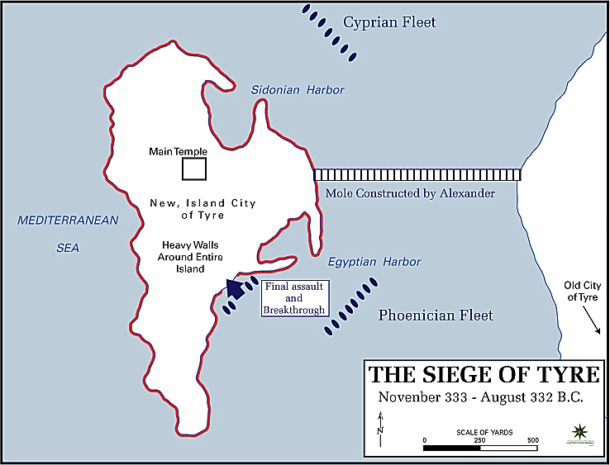

Before we consider the further lessons in Ezekiel 27, we want to present a symbolic interpretation:

- The first phase of the destruction of Tyre on the mainland represents the destruction in WW1 of Papacy’s centuries long relationship with the monarchical kings of Europe.

- As Tyre rebuilt itself on the island and once again had relationships with many nations, so, also, Papacy, after a period of 70-years (pictured in Isaiah 23), has rebuilt its relationships with many nations of the world and has regained her financial strength, including estimated trillions of dollars in property around the world. Much of her global influence comes because some of her 1 billion adherents are influential business, financial and political leaders in many different nations.

- The second and final phase of Tyre’s destruction represents Papacy’s final destruction in the future.

- Even as Tyre had not ceased to exist between the two phases of her destruction, so, too, Papacy did not cease to exist after WW1, but rather was “forgotten” more or less by the world leaders until the beginning of the fall of Communism. This brought her back into world prominence as an important player in world affairs, even though the Vatican does not have an army of its own. One of the Vatican’s sought-after skills is as a deal maker or broker between nations, using their considerable influence.

Ezekiel 27 records both the reconstruction and the final destruction of Tyre on the island. First it relates how all the various named countries were their merchants, some of them even provided her with armies. They hung their shields all along the walls showing their unity and support with the city of Tyre.

We suggest that today the “merchants” are the financial kings (corporations, banks and large investors) working with the political kings and are really global elitists. They are not so interested in nationalities as in the past. They use nationality as part of their grand chess game. But they are really above nationality. They are interested in global control, and they think it will be good for the world if they’re in control because then they can hopefully minimize wars and conflicts. However, they are fully engaged in protecting their own assets and furthering their empires in their own way. We don’t have to worry about trying to understand all of that. It is enough that we know from scripture that Satan likes to reward those that he can work through by giving them the power of this world. These kingdoms are his and they will go down.

We will now consider some startling similarities between Ezekiel 27 and Revelation 18:

- Merchants and Merchandise:
Ezek. 27:3, 12-24:
“…which art a merchant of the people for many isles…”
In verses 12-24 about 37 different merchandise items are listed.
Rev. 18:3, 23, 12-14:
“…and the merchants of the earth are waxed rich…thy merchants were the great men of the earth…”
In verses 12-14 about 28 different merchandise items are listed.
- Kings of the earth:
Ezek. 27:33: “…thou didst enrich the kings of the earth…”
Rev. 18:3: “…the kings of the earth have committed fornication with her…”
- Mariners, sailors and seafarers:
Ezek. 27:8, 9: “The inhabitants of Zidon and Arvad were thy mariners, the wise men of Tyre that were in thee were thy pilots. The ancients of Gebal and the wise men thereof were in thee thy caulkers, all the ships of the sea with their mariners were in thee to occupy thy merchandise.”
Rev. 18:17: “…every shipmaster and all the company in ships and sailors, and as many as trade by sea…”
- Many different people:
Ezek. 27:3: “…people of many isles…”
Rev. 18:3: “…all nations…”
- Destruction in the sea:
Ezek. 27:26, 27: “Thy rowers have brought thee into great waters, the east wind hath broken thee in the midst of the seas…all thy company which is in the midst of thee, shall fall into the midst of the seas…”
Rev. 18:21: “And a mighty angel took up a stone like a great millstone and cast it into the sea…”
- Merchants, mariners and sailors wail:
Ezek. 27:29-33: “…and all that handle the oar, the mariners, and all the pilots of the sea…shall cause their voice to be heard against thee, and shall cry bitterly, and shall cast up dust upon their heads, they shall wallow themselves in the ashes…they shall weep for thee with bitterness of heart…and in their wailing they shall take up a lamentation for thee, and lament over thee saying, what city is like Tyre, like the destroyed in the midst of the sea? When thy wares went forth out of the seas…thou didst enrich the kings of the earth…”
Rev. 18:11, 15-19: “And the merchants of the earth shall weep and mourn over her, for no man buyeth their merchandise any more…the merchants of these things which were made rich by her, shall stand afar off for the fear of her torment, weeping and wailing…for in one hour so great riches is come to naught. And every shipmaster and all the company in ships, and sailors, as many as trade by the sea stood afar off and cried when they saw the smoke of her burning, saying what city is like unto this great city! And they cast dust on their heads and cried, weeping and wailing, saying alas, alas, that great city wherein were made rich all that had ships in the sea…”
- Kings afraid at her destruction:
Ezek. 27:35: “…their kings shall be sore afraid…”
Rev. 18:9, 10: “And the kings of the earth…shall bewail her…standing afar off for the fear of her torment…”
- Exalted, then destroyed:
Ezek. 27:26: “Thy rowers have brought thee into great waters: the east wind hath broken thee in the midst of the seas.”
Rev. 18:21: “And a mighty angel took up a stone like a great millstone and cast it into the sea, saying, thus with violence shall that great city Babylon be thrown down…”
- Found no more:
Ezek. 27:36: “…and never shalt be anymore”
Rev. 18:21: “…and shall be found no more at all.”

Summary observations:

Both demonstrate that at the time (future), when Papacy and her daughters, the Protestant Church systems, are destroyed, they are financially involved on a global scale.

They have illicit relations with the kings/world leaders.

We note that ancient Babylon was not situated on the sea, but rather on the river Euphrates. But the Revelator states that her merchants were those who “trade by sea” and her destruction was to be “cast into the sea.”

It seems that the Lord wants us to make a connection between Tyre and Babylon, so as to learn this aspect of the two phases of the nominal Church’s destruction.

Brethren, this lesson regarding Tyre’s destruction, rebuilding, and later final destruction is meant to be a great encouragement to us regarding the long passage of time since 1914. The world events of today, as well as Bro. Russell’s prophetic presentation from his 1916 Foreward of the Fourth Volume, “The Battle of Armageddon, written only 30 days before his death and graduation, and two years before the Great War would end (even before the USA entered the war) show that his expectations are still valid.

Quotes from the 4th Volume 1916 Foreword.
Page ii: “Already the kings, political and financial, and their advisers, are in great perplexity respecting what shall be done after the close of the war to prevent a world-wide revolution of the discontented.”
“The Bible points out that about this time the Nominal Church systems of the world will rise to great prominence again in connection with the Civil powers. We can readily see the grounds for this. All the kingdoms, financially weakened, will realize the necessity for keeping a dominating grip upon the public and preventing anything akin to Socialism and Anarchy. They will naturally look to the great religious institutions called Churches to support them…”
Page iii: “But the Bible declares that this reign ‘as a queen’ will be a short one, and that the fall of Babylon will be tremendous – like a great millstone cast into the sea. It will be during the power of this so-called ‘queen’ for a little season, that the world will be under a great strain as respects any presentation of the Truth. And those found loyal to God and to principle will doubtless suffer therefore.
“At the time of Babylon’s fall, the mighty ones of the earth, financial and political princes and kings, will stand afar off, keeping clear of too close an affiliation with her, although they will greatly lament her destruction, realizing that it forebodes their own. Then very shortly will come the complete overthrow and destruction of the present Gentile governments, symbolically represented in the Bible as a great conflagration which will consume the whole earth – all institutions – religious, social, political, and financial.”

Bro. Russell, repeatedly says “the Bible points out” and we think he’s primarily referring to the book of Revelation. Revelation demonstrates that the Lord starts working with the world of mankind after the completion of the church, after the completion of the Great Company, and right after the final destruction of the nominal church systems, the governments and the financial systems of earth. Comparing these thoughts with the Divine Plan of The Ages chart, we see that Bro. Russell did not think that there would be a long period of time between these closing events and the mediatorial reign of the kingdom of peace.

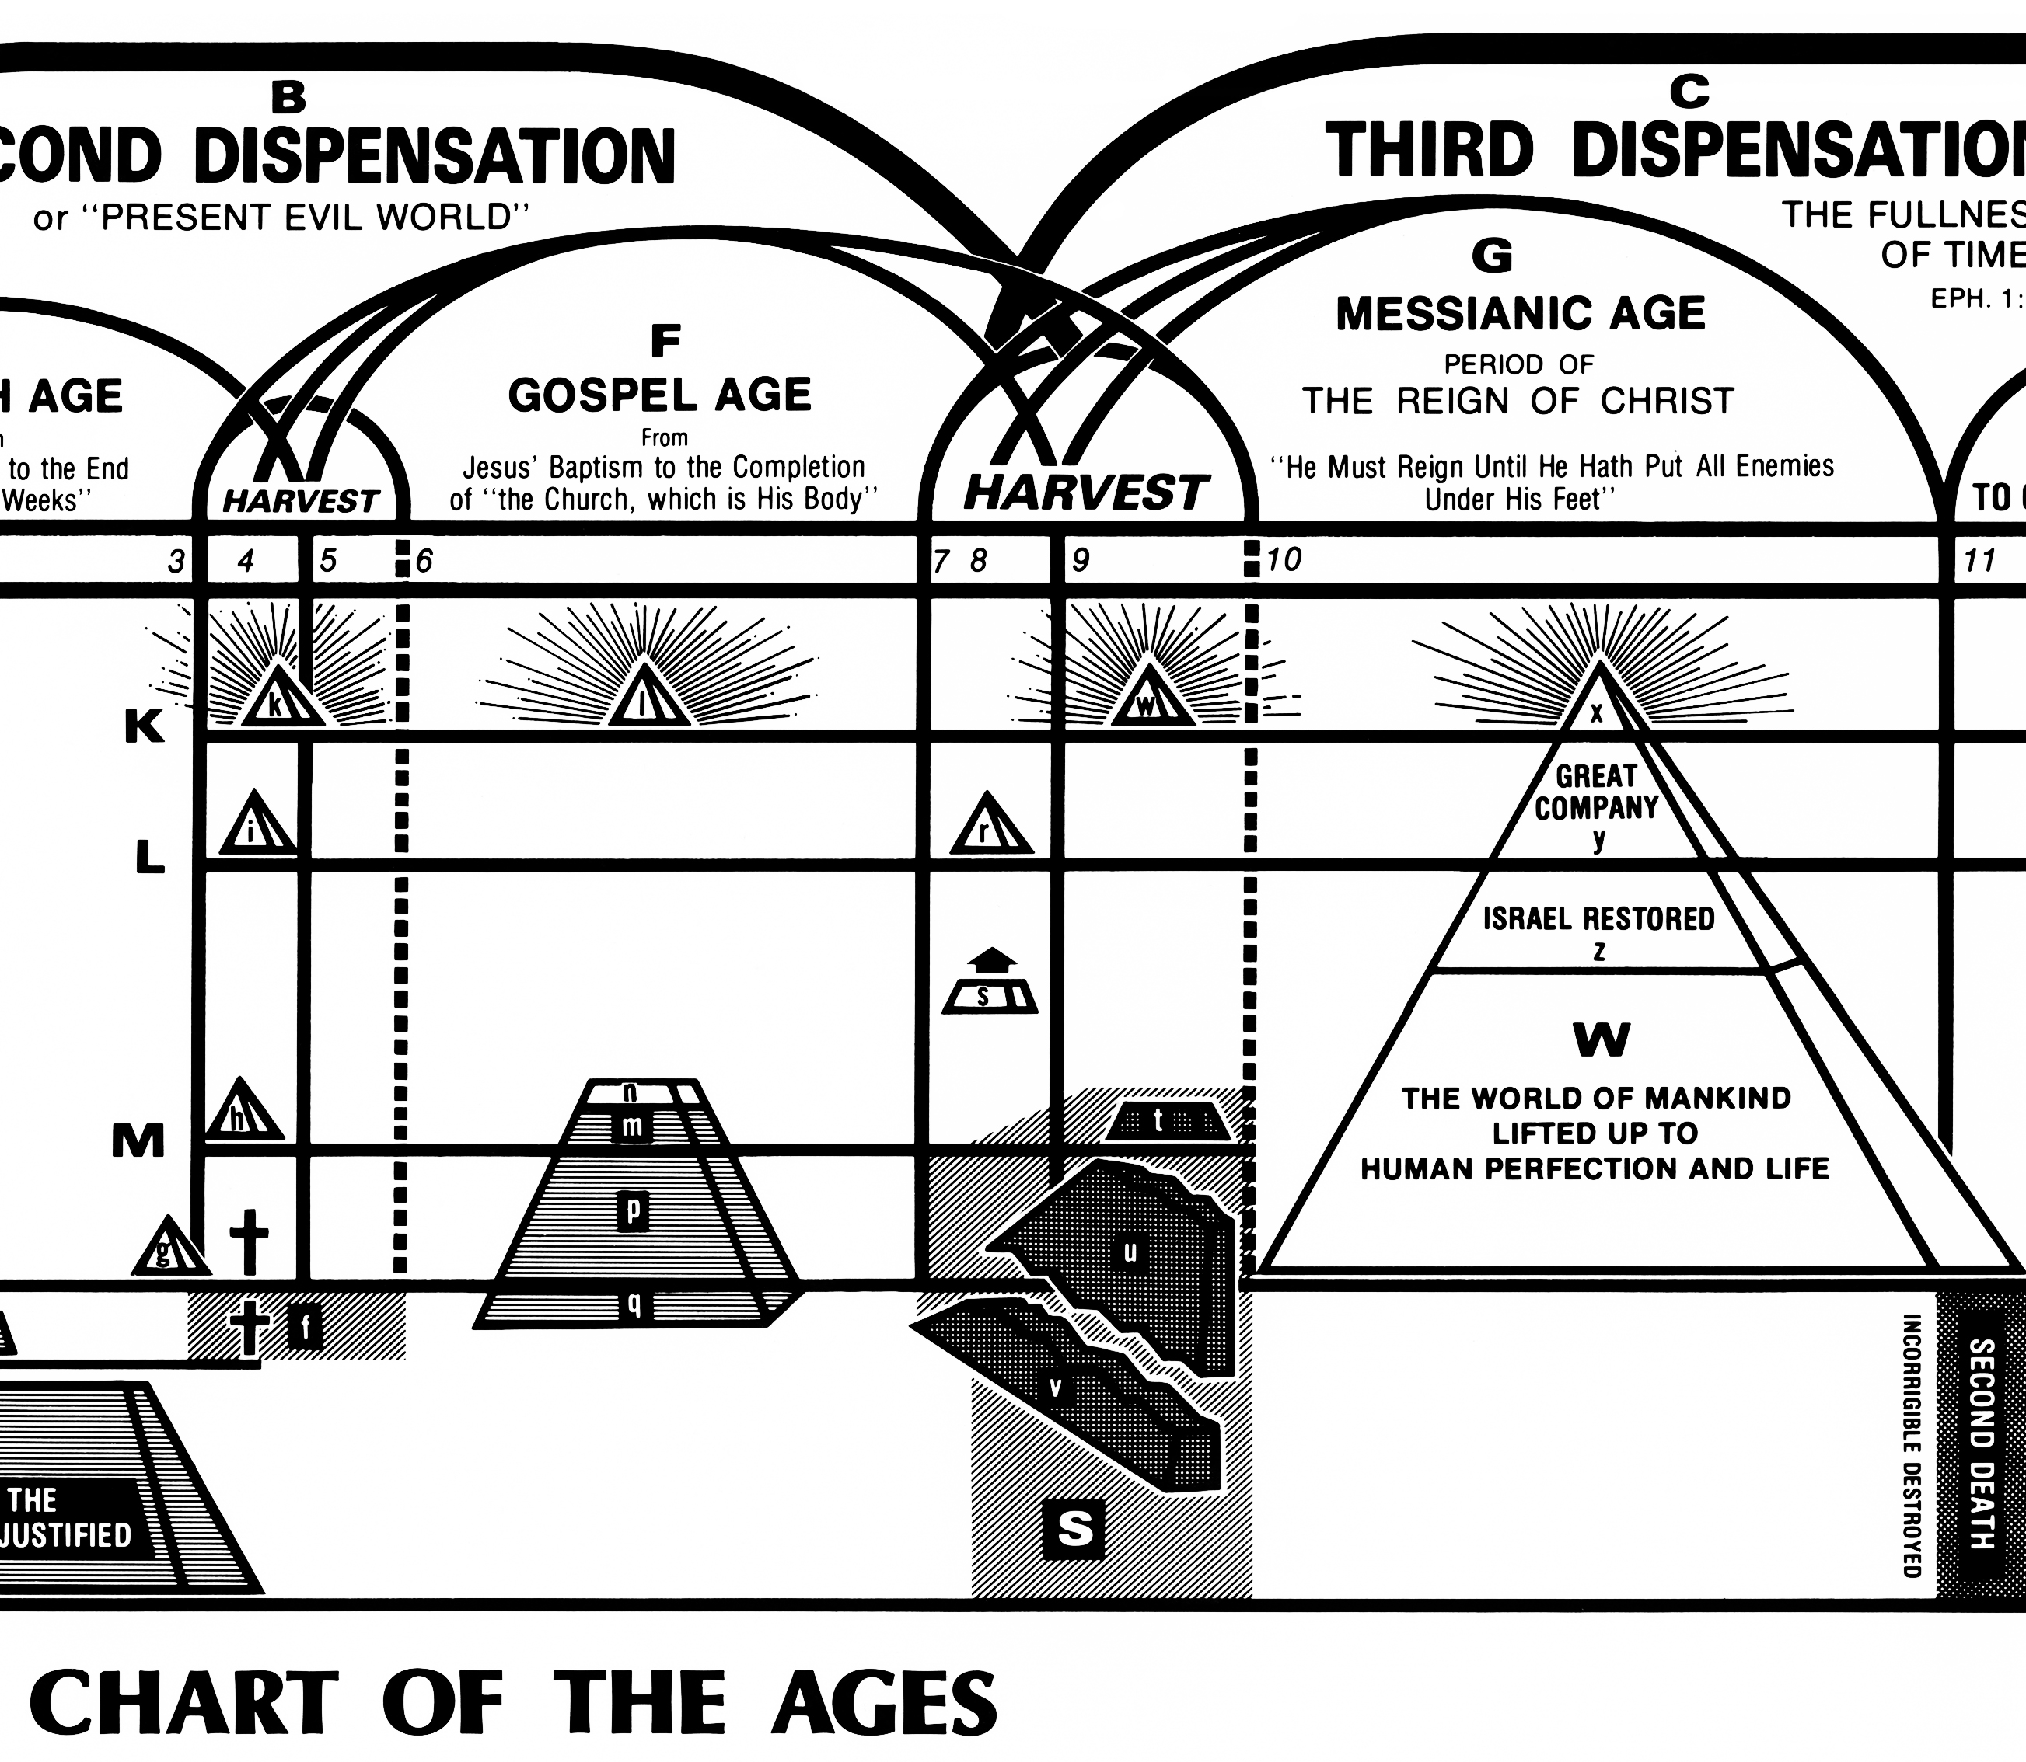

Note that Bro. Russell states that it is after the close or end of the war that the Churches will rise again to great prominence with the civil powers and will “sit as a queen” “for a little season,” before her final destruction. We believe that this is still ahead of us.

Perhaps one of the pictures in Revelation that Bro. Russell was referring to is Chapter 17:12-14: “And the ten horns which thou sawest are ten kings which have received no kingdom as yet, but received power as kings one hour with the beast. These have one mind, and shall give their power and strength unto the beast. These shall make war with the Lamb, and the Lamb shall overcome them: for he is Lord of lords and King of kings, and they that are with him are called, and chosen, and faithful.”

Chapter 17 presents that there are kings past (pre 1914) and kings future. This is in harmony with our previous lesson regarding the two phases of Tyre’s destruction. Also, from Isaiah 23 we’ve seen that Tyre would return to her hire, etc.

These ten kings are post 1914 kings or civil powers. Currently they do not have power as the kings of old. But, for a short period of time, they will have control like the kings of old and will give their support to a Church and State form of government. This government will then proceed to persecute the final “Feet Members of the Body of Christ,” who, like their Head before them, will be faithful unto death, hence completing the great Messiah, head and body, and hence leading to the final destruction of these present governments of earth, the old heavens and old earth passing away during the Armageddon crash.

In a similar way we can use the example of Herodias, Salome and Herod who persecuted John the Baptist. Herod pictures civil government, or these kings who had had no power as yet. Herodias represents the Papacy. Herodias had previously been married to Herod’s brother, Philip. Herodias improperly separated from him and married Herod. The message of John the Baptist was that this is an illicit relationship. Salome (we only get her name from Josephus) represents the “harlot daughters”—Protestant systems. The Protestant systems along with the Papacy, the mother (mother and daughter harlots) persuade a reluctant civil power (Herod) to persecute John the Baptist (the final feet members of the Church). Herod represents these ten kings who had had no power as yet. Philip represents the previous kings, the monarchs, with which Herodias (the Papacy) had had a previous relationship. That relationship was done away with as a result of WW1. Papacy regroups ( like Jezebel painting her face). And she aligns herself once more for a short period of time with these future kings for this final hour of power.

Brethren, these prophetic suggestions are just that, suggestions, for you to consider. If it comes to pass differently, then undoubtedly it will be to the LORD’s greater glory.
May the Lord add His blessing.

